# Practical 1 A

**Perform conditional formatting on a dataset using various criteria.** Step 1: Create the Dataset

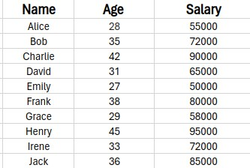

Step 2: Choose a Specific or Entire part from the dataset to apply conditional formatting. Then, click on the Conditional Formatting option.

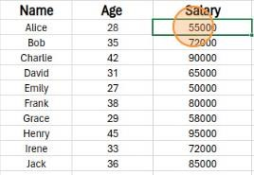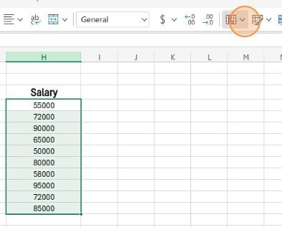

Step 3: Choose from the available options to select various types of conditions or create your own. opt for the colour scales option.

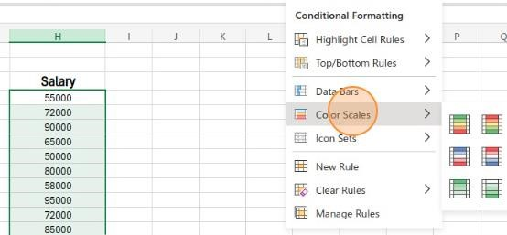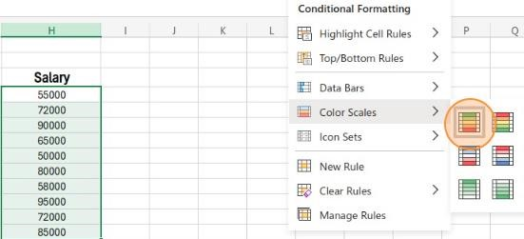

Step 4: After selecting the 'Green-Yellow-Red' option for colour scale conditional formatting in Excel, the conditional formatting should take effect.

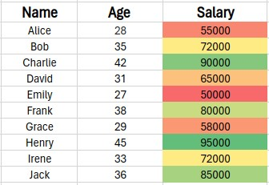

Step 5: To add other Conditional Formatting click on the conditional formatting icon again and choose the data bar option

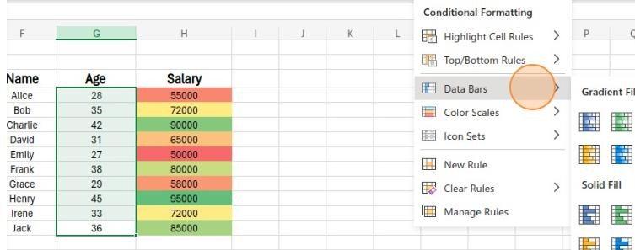

Step 6: The Conditional Formatting should have taken effect

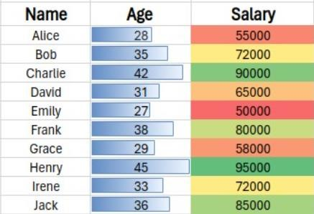

**B**

**Aim: Create a pivot table to analyze and summarize data.**

Step 1: Select the dataset to create the pivot table and analyze & summarize the data.

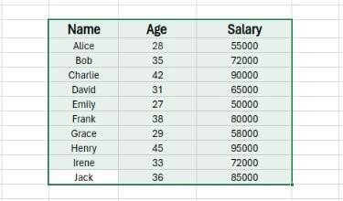

Step 2: In the Insert Section Click on Pivot table and select the existing workshop option

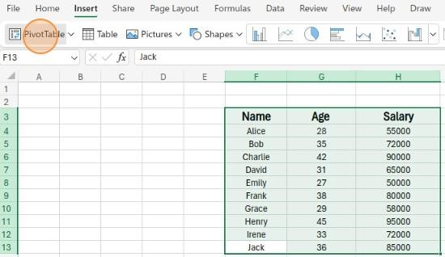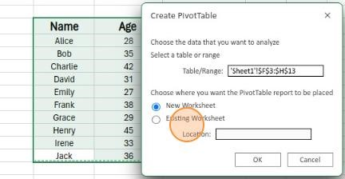

Step 3: After in the Pivot table creation section click the columns you to analyze & summarize and, in the value, section select the values you display

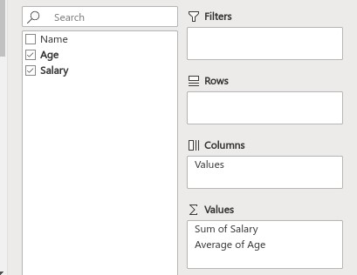

Step 4: The Pivot Table is displayed, presenting the sum of salaries and the average ages

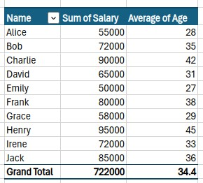

**C**

**Use the VLOOKUP function to retrieve information from a different worksheet or table.**

Step 1 Ensure you have two tables - one with the primary data (e.g., Student Name, Exam Number, Roll Number) and another where you want to perform the lookup.

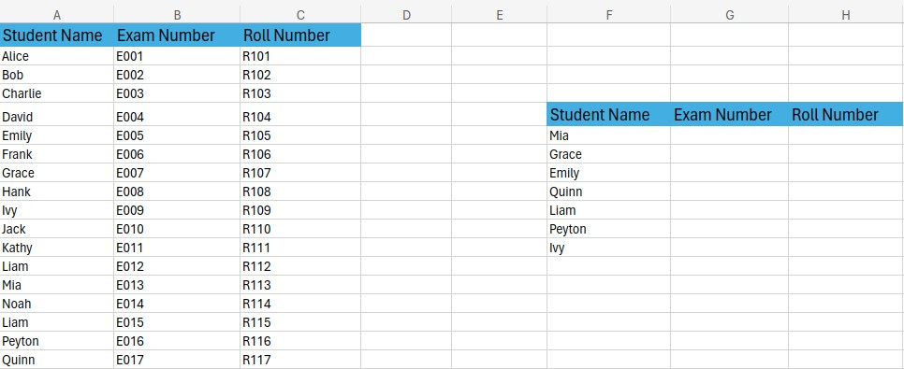

Step 2: Choose the cell in the second table where you want to enter the VLOOKUP formula

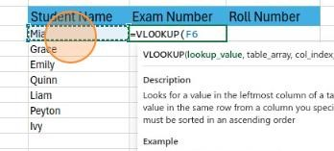

Step 3: Enter the following formula in the chosen cell

=VLOOKUP(F2, $A$2:$C$30, MATCH(G1, $A$1:$C$1, 0), FALSE)



Step 4: Drag the fill handle to copy the formula to other cells if you have multiple names to look up.

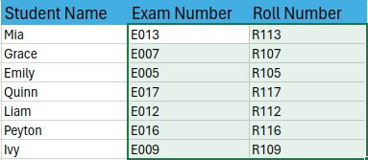

Step 5: Check the results to ensure accurate retrieval from the first table for corresponding names in the second table.

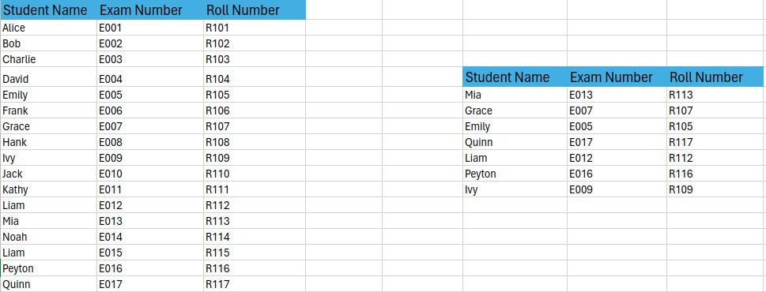

**D**

**Aim : Perform what-if analysis using Goal Seek to determine input values for desired output.**

Step 1: Create a Dataset

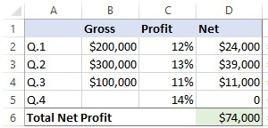

Step 2: Go to the Data tab > Forecast group, click the **What if Analysis** button, and select **Goal Seek…**

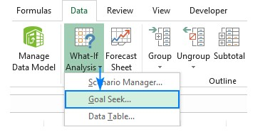

Step 3: In the Goal Seek dialogue box, define the cells/values to test and click OK

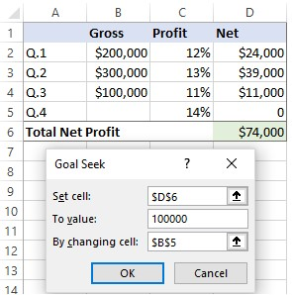

Step 4: Results

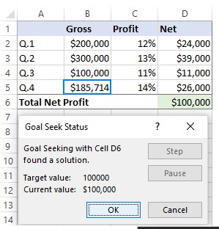

# Practical 2

Aim: Read data from CSV and JSON files into a data frame.

* Perform basic data pre-processing tasks such as handling missing values and outliers.
* Manipulate and transform data using functions like filtering, sorting, and Grouping

Program:

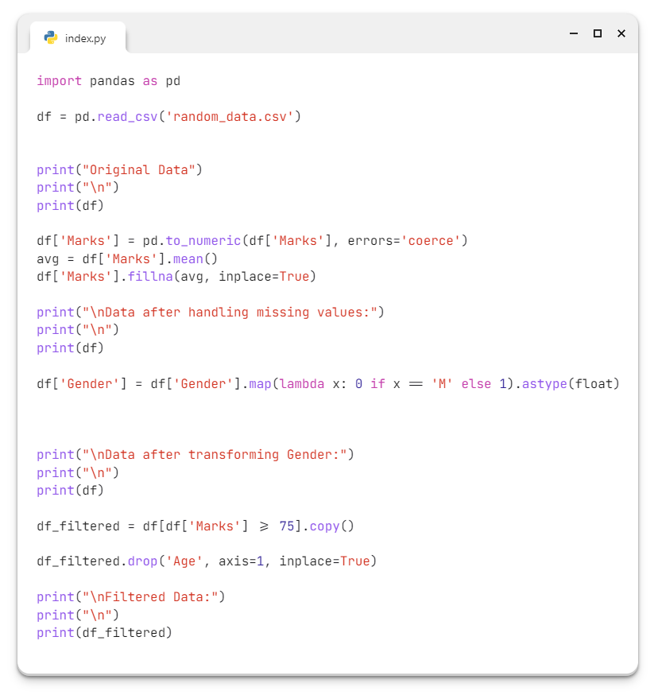

## Random_data.csv

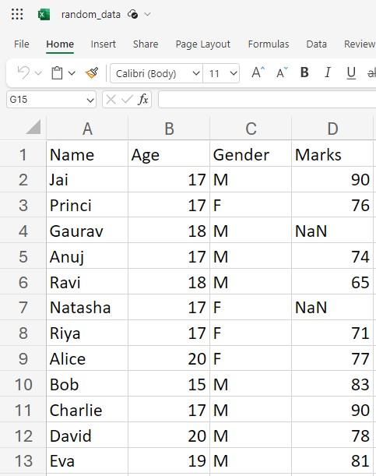

# Practical 3 A

**Apply feature-scaling techniques like standardization and normalization to numerical features.**

## Program

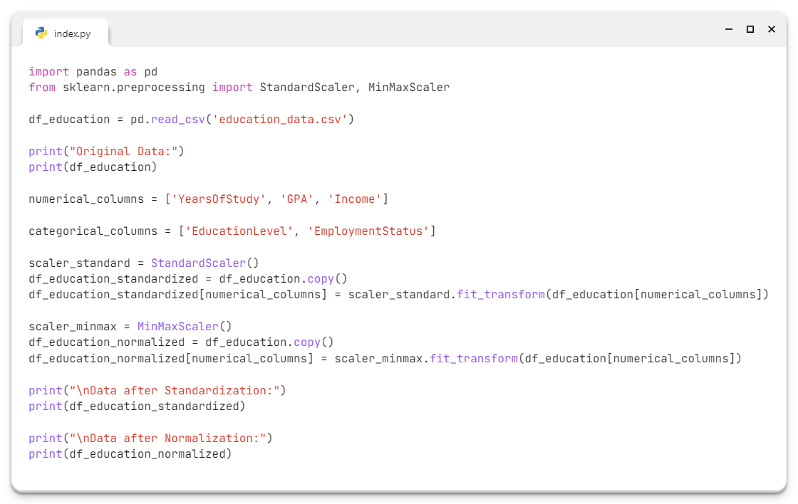

## Education_data.csv

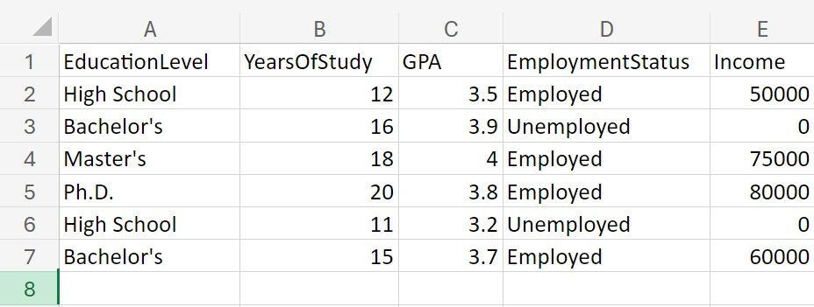

# Practical 3 B

**Aim:****Perform feature dummification to convert categorical variables into numerical representations**

Program:

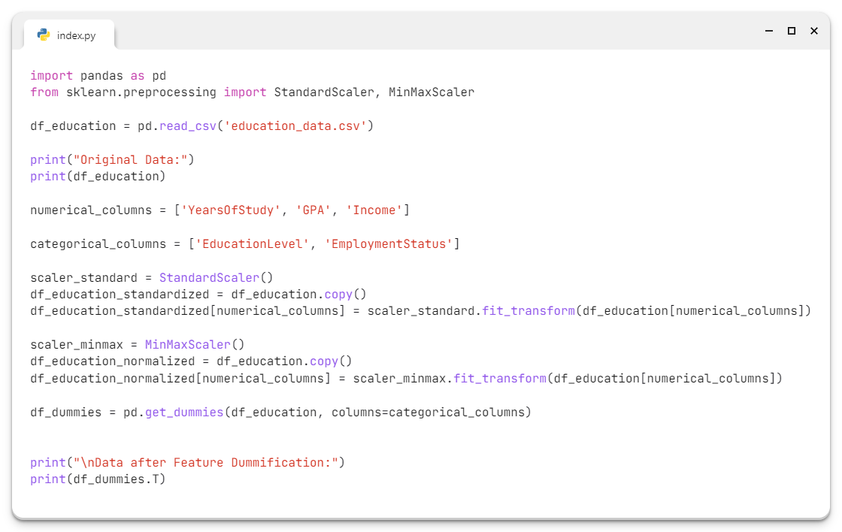

## Education_data.csv



# Practical 4 A

**Create a Python program showcasing the application of various data science libraries like sweetviz,geopandas and pycountry**

Program:

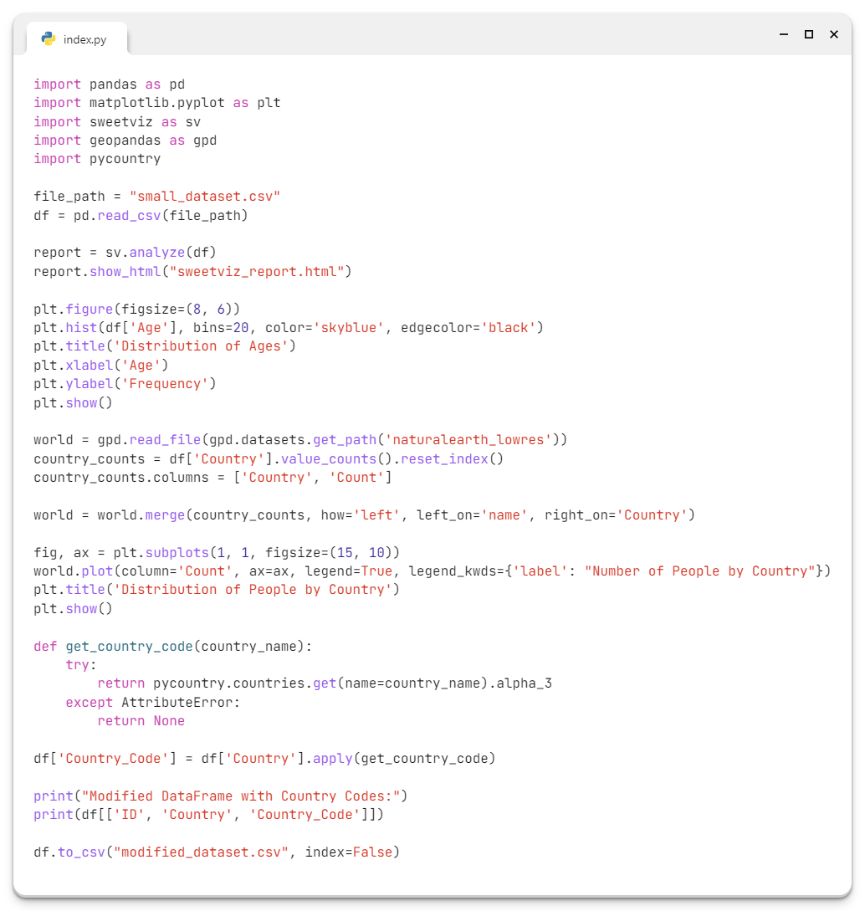

## Small_dataset.csv

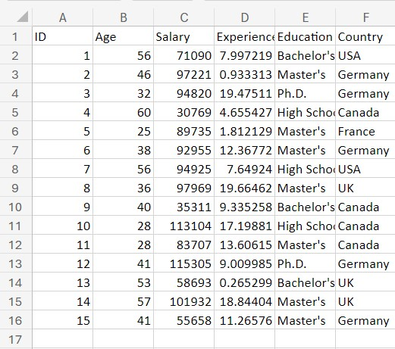

# Practical 4 B

**Create a Python program showcasing the application of various data science libraries like pyforest,dtale & Plotly**

**Program:**

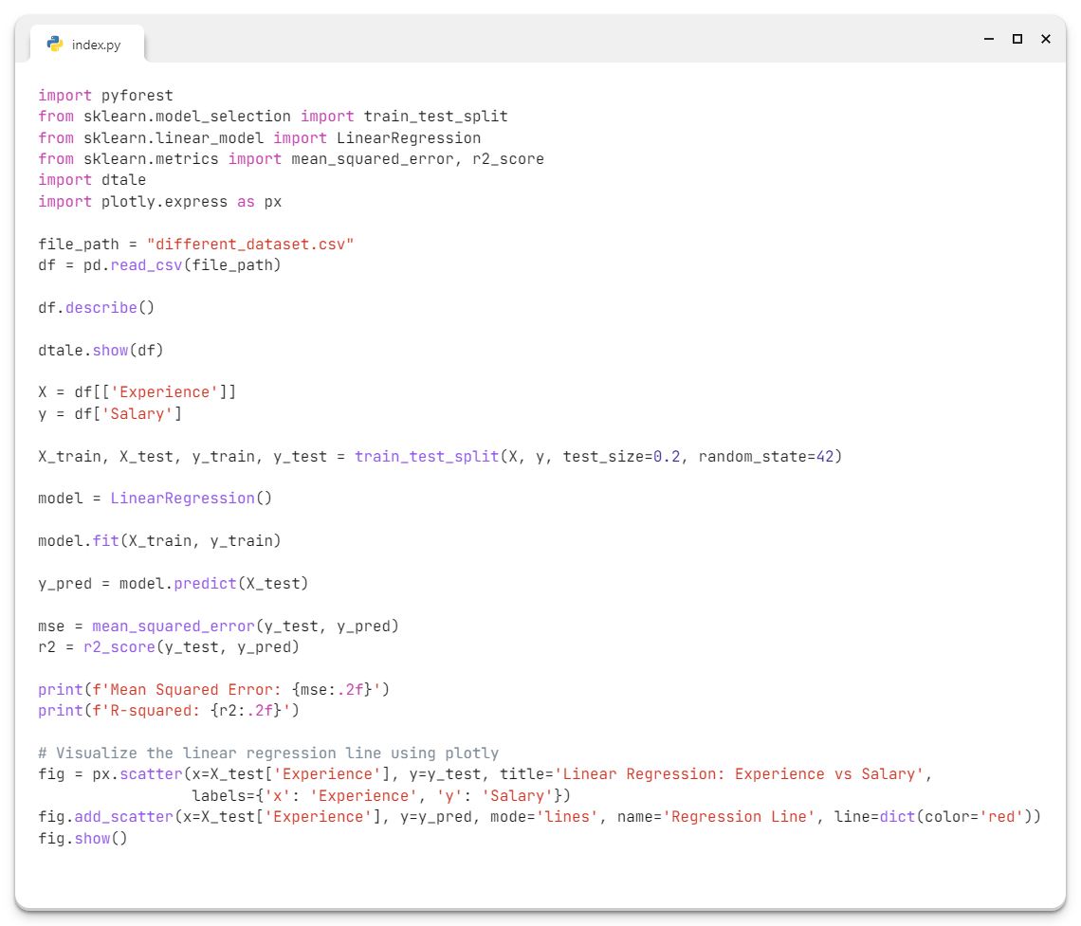

**Different_dataset.csv**

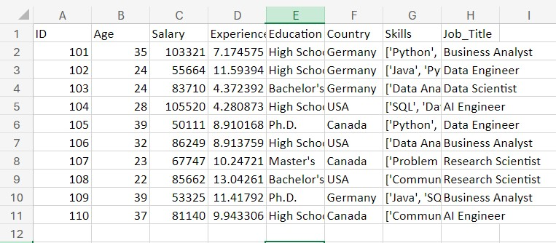

# Practical 5 A

**Formulate null and alternative hypotheses for a given problem**

**Program:**

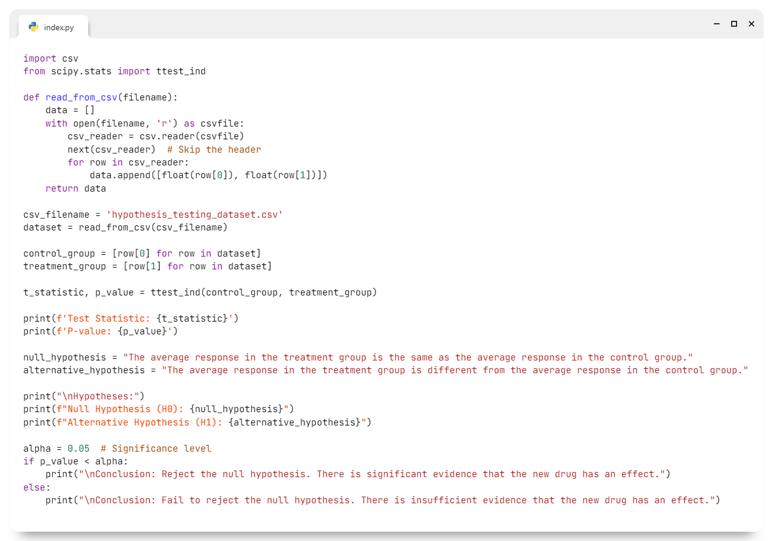

**hypothesis_testing_dataset.csv**

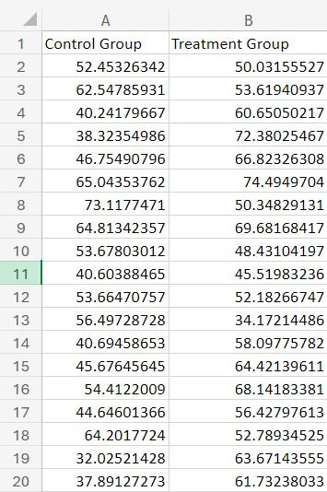

# Practical 5 B

**Conduct a hypothesis test using appropriate statistical tests (e.g., t-test, chi-square test).**

**Program:**

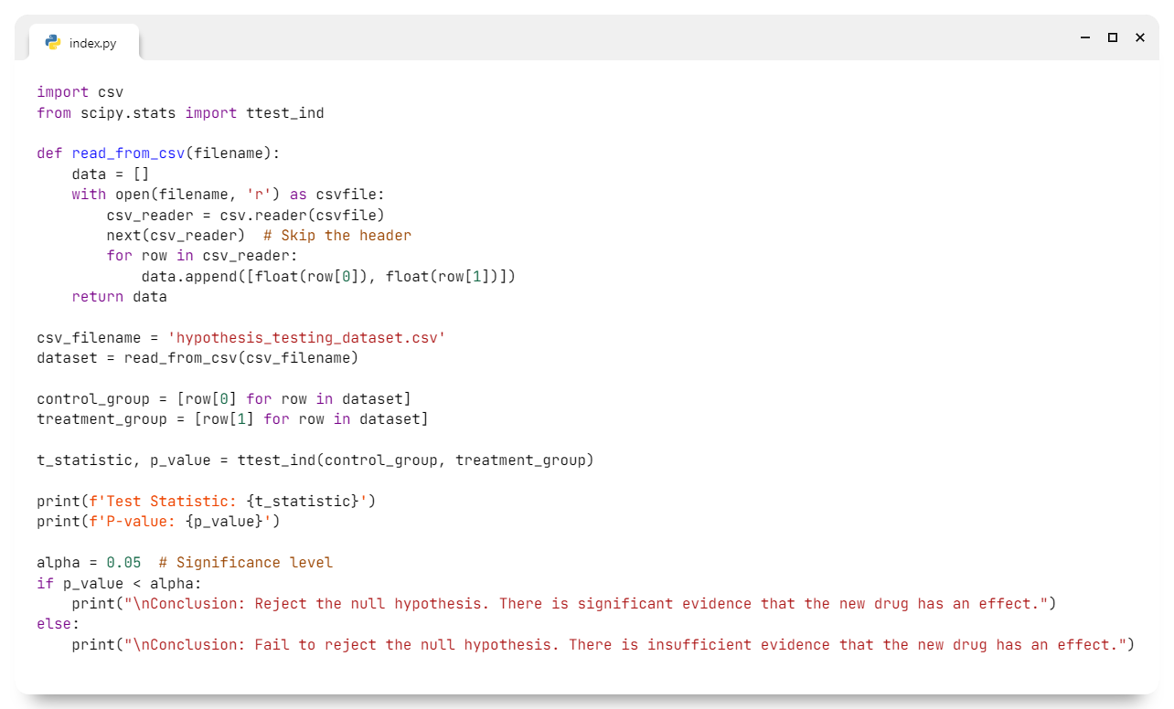

**hypothesis_testing_dataset.csv**



# Practical 5 c

**Aim: Interpret the results and draw conclusions based on the test outcomes.**

Program:

